DCG vs. Bondurant Farrar
Friday, September 3rd, 2021

Event Information
Level 9th/Varsity Football
Location DCG Stadium (2555 W. 1st St.)
Grimes, Iowa 50111
Gates Open 4pm
Start Time 9th – 4:15pm Varsity 7pm
Uniforms Home – DCG (Dark) Away – BF (Light)
Tickets $5.00 for Adults and $5.00 Students (Below KDG no charge)
Tickets will be sold at the gate or online using this link
https://ia.varsitybound.com/schools/dallascentergrimes/tickets

Event Timeline for Freshman

4:15PM Freshman Kickoff vs. Bondurant Farrar

Varsity Pre-Game
5:45PM FIELD AVAILABLE FOR WARMUP AT THE CONCLUSION OF THE 9TH GRADE GAME
6:15PM START THE GAME CLOCK
SET CLOCK TO 45:00 AND START. WILL NOT START VARSITY GAME BEFORE 7:00PM.
6:30PM DCG SENIOR NIGHT FOOTBALL AND CHEERLEADING

GAME
CLOCK
45:00 BEGIN CLOCK - BONDURANT FARRAR – North Warm Up, East Bench (Enter S Gate to field)
DCG – South Warm Up, West Bench (Enter S Gate to field)
30:00 DCG Senior Night for Football and Cheerleading
20:00 Captains and officials meet for coin flip, football teams to team rooms
15:00 Teams clear the field for the DCG Marching Band
14:00 DCG Fight Song
12:00 Opponent Fight Song
10:00 National Anthem
5:00 Teams enter the field (Bondurant Farrar followed by DCG)
3:00 Mock Coin Flip
0:00 Kickoff

HALFTIME OF VARSITY GAME

GAME CLOCK
15:00 Put 15 Min. On Clock When Both Teams Have Left the Field.
DC-G Dance Team
Band

0:00 PUT AN ADDITIONAL 3:00 ON THE CLOCK FOR WARM-UP.

POST GAME
DCG – Exit South Gate
BONDURANT FARRAR – Exit South Gate and return to Meadows

35-Point Rule
This rule applies to anytime during the football game, grades 7-12 NEW RULE in 2020

Anytime the score differential reaches 35 points or more

*Beginning with the ensuing kick-off the following changes and only these will be made regarding rules determining when the clock will and will not be stopped. The clock will run continuously except for the following situations when it will be stopped:
- Any time-out charged to a team (re-start with the ensuing snap)
- After a score [re-start clock w/ ensuing kick-off when legally touched by returner or ensuing snap (kick-off out-of-bounds or a touchback)]
- Intermission between 3rd and 4th quarter (re-start with snap)
- Extended injury time-out - only if coach is brought out (re-start with ready for play)
- Anytime officials deem it necessary for safety reasons (re-start with ready for play)
- Normal clock procedures will resume when a team scores to make the point differential less than 35 points!
NOTE: In accordance with Rule 3-1-3, any remaining periods may be shortened or terminated by mutual agreement between the opposing coaches and referee.

Event Management – Personnel

Athletic Staff
Activities Director Mr. Brent Buttjer Cell Phone – 515-249-5884
Asst. AD/Events Coordinator Ms. Madison Melchert Cell Phone – 515-250-7988
Secretary/Ticket Mgr. Ms. Shauna Pertzsch
Principal Mr. Scott Blum Arrival Time 5:45pm
Dean of Students Mr. Travis Donahue 5:45pm
Location DCG Stadium

Meadows Administrators
Principal Dr. Lori Phillips
Dean of Students Mr. Marc Juergens
Arrival Time 6:30pm
Middle School Administrators
Principal Mr. Jerry Hlas
Arrival Time 6:30pm
Elementary Administrators ALT
Principal Ms. April Heitland Superintendent Mr. Scott Grimes
Principal Ms. Debra Cale Asst. Superintendent Ms. Jill Van Woerkom
Principal Ms. Diann Williamson Building and Grounds Mr. Daryl Haynes
Principal Ms. Patty Morris Building and Grounds Mr. Sean Shatava
Arrival Time 6:30pm

Security
Player Gate Assigned
Dallas Co Sherrif Capt. Doug Miller Douglas.Miller2@polkcountyiowa.gov
CSC Lead Ms. Sami Hiatt – 515-954-6347
Arrival Time 4:30pm

Athletic Trainer and EMS
Trainer Jerod Torrey, ATC
Location DCG High School Sideline
Special Instructions Available for both teams during competition
Johnston and Grimes EMS Ron Shipper 515-201-9658

Iowa Ortho Doctors
Doctor Dr. Jason Sullivan – Iowa Ortho
Doctor Dr. Dennis Bussey – Unity Point
Location DCG High School Sideline
Special Instructions Available for both teams during competition

Game Officials
Host – (Will dress in nurses office at West HS). Arrive at 5:30pm
Varsity Game Scott Brown Crew – scott.brown@ag.iowa.gov
FB Assignor Larry Jacobus 515-490-0779(C)/email: piratespen@msn.com

Event Management – Visiting Team Information

Team Greeter – Mr. John Klaessy Approximate arrival for Bondurant Farrar Varsity 5:15-5:30pm…Report at 5pm

Team Buses
- 9th grade bus park on the south side of the football field by orange cones behind scoreboard. Lockeroom available after Varsity clears.
- Varsity Buses will be greeted/ directed by stadium personnel on the S side of Meadows (See map below)
- Team will be dropped off and proceed to the lockeroom on the S side of Meadows. (See map below)

Locker Room
Visiting Team Buses should drop on the south side of Meadows and event personnel will assist getting them into lockerooms. (See map below)

Pre Game and Halftime Team Room
Behind SE visitor concessions (See map below)

Press Box
Visiting Coaches will be in the north press box with their filming crew.

Warm-Up and Bench
Visiting teams will warm-up on the North end of the field and will occupy the east sideline
DCG will warm-up on the South end of the field and will occupy the west sideline.
Our team host and trainers will assist your managers with bringing equipment to the field. Water can be filled at the spicket on the south end of the stadium.

Event Management – Spectator Information

Spectators
- All visiting spectators are asked to enter stadium thru the Southeast gates (See map below for parking)
- Student and Parent Home seating is on the West side of the stadium
- Student and Parent Visitor seating is on the East side of the stadium
- Ticket sales will be at the gate or online using this link
  - https://ia.varsitybound.com/schools/dallascentergrimes/tickets
- Gates will open at 4 pm.

Tickets
- All Spectators – $5.00 at the gate or online using this link:
  - https://ia.varsitybound.com/schools/dallascentergrimes/tickets
- No re-entry to stadium for students.

SEE MAP BELOW
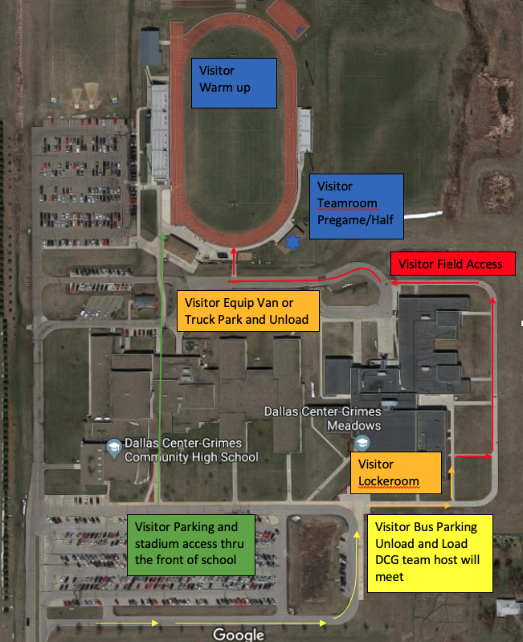
Coaches Quick Look
DCG vs. Bondurant Farrar
Game Field may be accessed at 5:45pm or after 9th grade game
Clock
45:00 Game Clock Starts
15:00 Teams off field
14:00 DCG Band Fight Songs and Anthem
5:00 Bondurant Farrar (S Gate)
4:00 DCG (S Gate)
3:00 Mock Coin Flip
0:00 Kickoff
Halftime 15min

